the static keyword can be applied to the
following:
Data of a class
Methods of a class
Properties of a class
A constructor
The entire class definition

Most of the time when designing a class, you define data as instance-level data; said another way, as
nonstatic data. When you define instance-level data, you know that every time you create a new object,
the object maintains its own independent copy of the data. In contrast, when you define static data of a
class, the memory is shared by all objects of that category
Static data, on the other hand, is allocated once and shared among all objects of the same class
category.

Eg saving a/c interest 4.3 for all
Balanceamt/ instance data
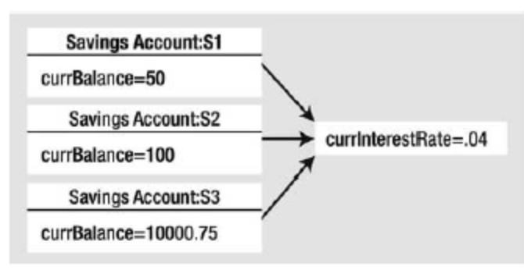

Here, our assumption is that all saving accounts should have the same interest rate. Because static
data is shared by all objects of the same category, if you were to change it in any way, all objects will
“see” the new value the next time they access the static data, as they are all essentially looking at the
same memory location.
the CLR will allocate the static data into memory exactly one time.

Static constructor
This approach will ensure the static field is assigned only once, regardless of how many objects you
create. However, what if the value for your static data needed to be obtained at runtime? For example, in
a typical banking application, the value of an interest rate variable would be read from a database or
external file. To perform such tasks requires a method scope such as a constructor to execute the code
statements. For this very reason, C# allows you to define a static constructor, which allows you to safely set the
values of your static data

Simply put, a static constructor is a special constructor that is an ideal place to initialize the values
of static data when the value is not known at compile time (e.g., you need to read in the value from an
external file, a database, generate a random number, or whatnot

Here are a few points of interest regarding static constructors:
A given class may define only a single static constructor. In other words, the static
constructor cannot be overloaded.
A static constructor does not take an access modifier and cannot take any
parameters.
A static constructor executes exactly one time, regardless of how many objects of
the type are created.
The runtime invokes the static constructor when it creates an instance of the class
or before accessing the first static member invoked by the caller.
The static constructor executes before any instance-level constructors

Defining Static Classes
It is also possible to apply the static keyword directly on the class level. When a class has been defined
as static, it is not creatable using the new keyword, and it can contain only members or data fields
marked with the static keyword. If this is not the case, you receive compiler errors.
 Note Recall that a class (or structure) that only exposes static functionality is often termed a utility class. Whendesigning a utility class, it is good practice to apply the static keyword to the class definition.

